Supplementary Fig. 1. Indications for study participants initiating warfarin for anticoagulation

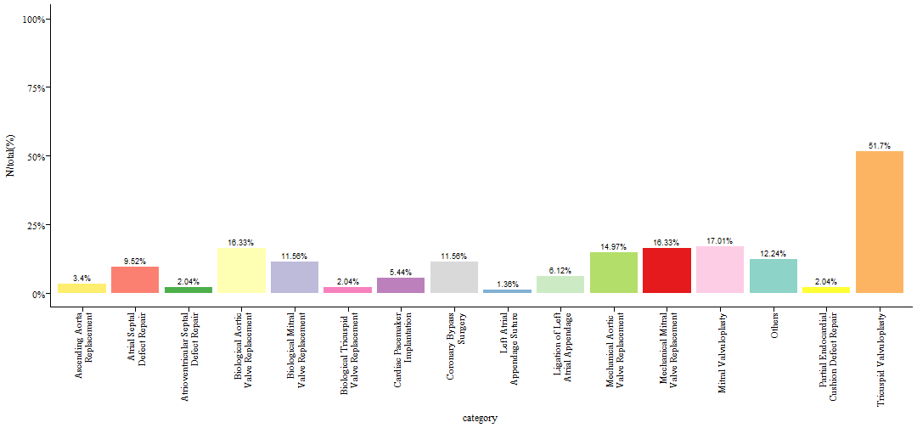

Supplementary Fig. 2. Classes of concomitant medication for study participants initiating warfarin for anticoagulation

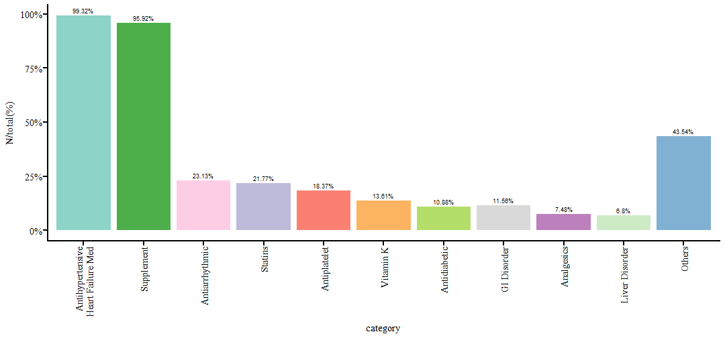

Supplementary Fig. 3. Diagnostics plots for the K/PD final model: a) observed versus individual predictions for INR, b) observed versus population predictions for INR, c) CWRES INR versus Time (Day), d) CWRES versus population prediction for INR. CWRES, conditional weighted residuals.
a) b)
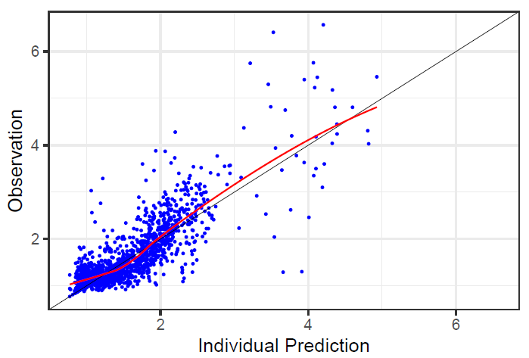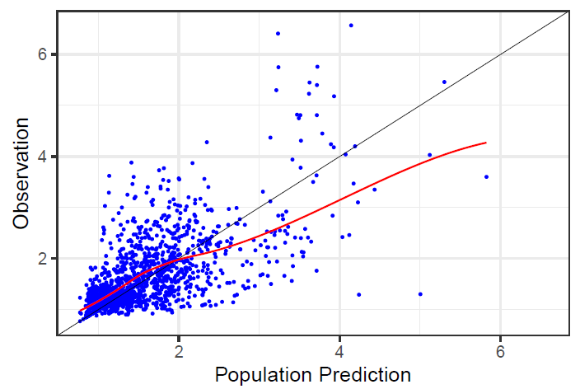
c) d)
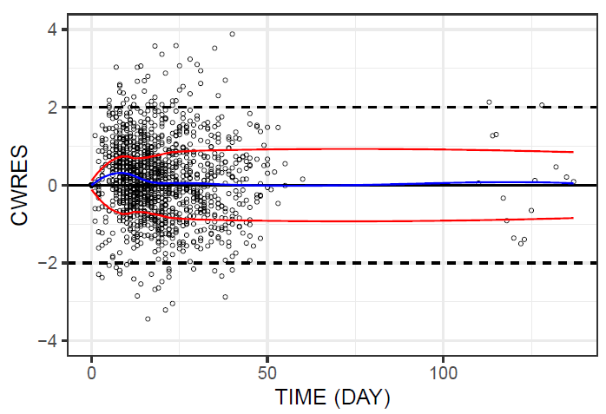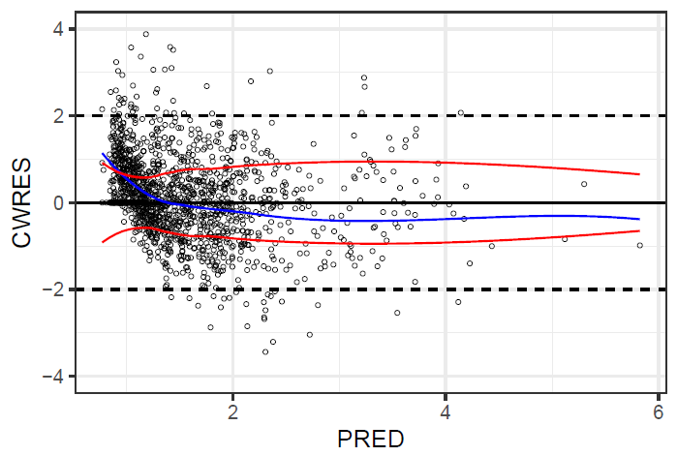

Supplementary Fig. 4. Representative plots for individual INR predictions versus Time (day).
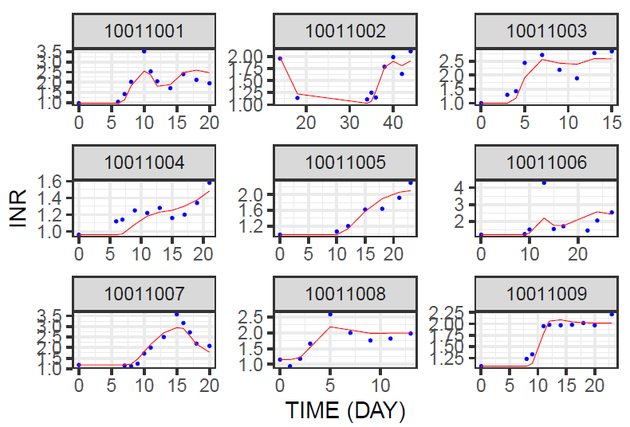
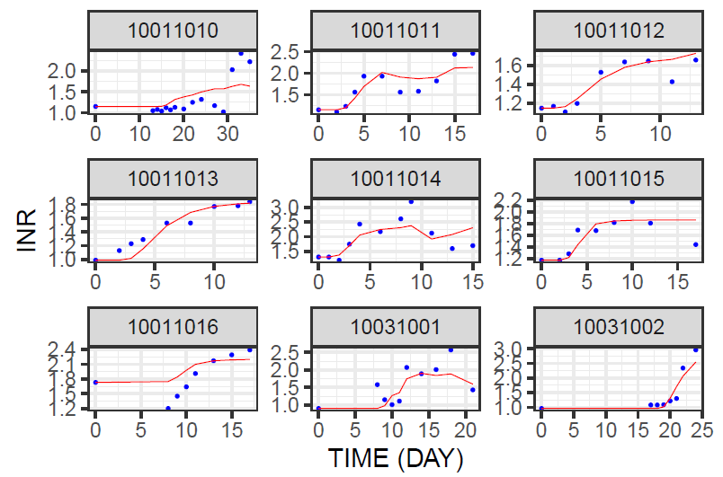

Supplementary Fig. 5. INR-time series simulations for typical Chinese individuals of the most common VKORC1 and CYP2C9 genotypes, who are 1.65 m tall and weighs 65 kg, receiving the AI-Optimized pharmacogenetics-guided dosing regimen shown in Table 4.
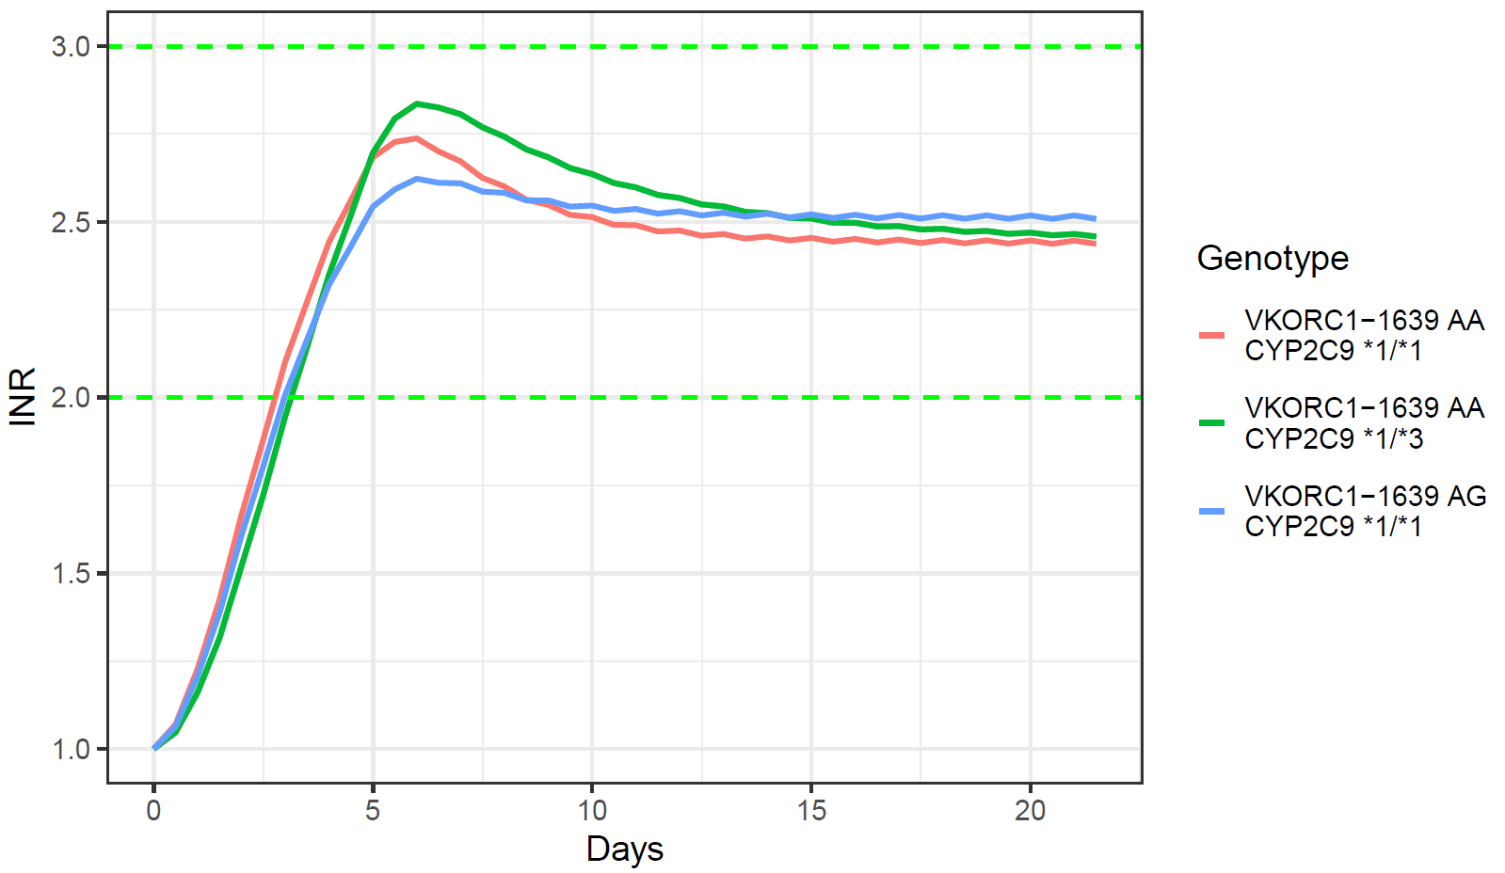

Supplementary Table 1. Covariate relationships for consideration to be included in K-PD model by forward (P<0.05) and backward (P<0.01) stepwise covariate search

Covariates for Consideration
- Vitamin K use on INR | - WT on V
- Age on CL | - WT on CL
- Age on EC50 | - WT on EC50
- Gender on EC50 | - HT on V
- Gender on CL | - HT on CL
- BSA on V | - HT on EC50
- BSA on EC50 | - Statin use on CL
- Amiodarone use on CL | - Statin use on EC50
- Smoking on EC50 | - Hemoglobin on CL
- Smoking on CL | - Hemoglobin on EC50
- Creatinine on CL | - GFR on CL
- Creatinine on EC50 | - EC50 on CL
- AST on CL | - ALT on CL
- AST on EC50 | - ALT on EC50
- Platelets on CL
- Platelets on EC50

Supplementary Code: AI-assisted Warfarin Dose Optimization Workflow

Example simulation code using mrgsolve package in R:

library(mrgsolve)

# Model specification ###################################################################################
mod <- mcode("warfarin_kpd",'
@annotated
@CENTRAL : CENTRAL
@EFF1 : EFF1 TRANS CPT1
@EFF2 : EFF2 TRANS CPT1
@EFF3 : EFF3 TRANS CPT1
@EFF4 : EFF4 TRANS CPT2
@EFF5 : EFF5 TRANS CPT2
@EFF6 : EFF6 TRANS CPT2

$PARAM @annotated
TVCL : 0.24 : Clearance (L/h)
CL_BSA : 2.14 : BSA on CL
CL_CYP : 0.543 : CYP2C9 effect on CL
TVV : 13.8 : Volume (L)
TVKA : 2 : Absorption rate (1/h)
EMAX : 1 : Maximum effect
EC50_G : 3.05 : EC50 for VKG genotype (mg/L)
EC50_A : 1.09 : EC50 for VKA genotype (mg/L)
GAM : 1.44 : Hill coefficient
MTT1 : 30.8 : Mean transit time 1 (h)
MTT2 : 30 : Mean transit time 2 (h)
INRRES : 0.218 : INR residual error
INRMAX : 20 : Maximum INR
VKDATE_COV: 0.896 : VKDATE covariate effect
V_BSA_COV: 2.38 : BSA on V
EC50_STAT_COV: 0.742 : STAT on EC50
CL_WT_COV: 0 : Weight on CL
@ covariate
HT : 0 : HEIGHT
WT : 0 : WEIGHT
CYP2C9 : 0 : CYP2C9
VKOR : 0 : VKOR
BASE : 0 : BASELINE INR
VKDATE : 0 : VKDATE
STAT : 0 : STATIN

$INIT
CENTRAL = 0, EFF1 = 1, EFF2 = 1, EFF3 = 1, EFF4 = 1, EFF5 = 1, EFF6 = 1

$OMEGA @annotated
ETA_KDE : 0 : IIV on KDE
ETA_EC50 : 0 : IIV on EC50
ETA_CL : 0 : IIV on CL

$SIGMA 0

$MAIN
double BSA = 0.007184 * pow(HT, 0.725) * pow(WT, 0.425);
double CYP2C9_3 = (CYP2C9 == 13 || CYP2C9 == 33) ? 1 : 0;

double TVEC50;
if(VKOR == 11) TVEC50 = EC50_G + EC50_G;
else if(VKOR == 13) TVEC50 = EC50_G + EC50_A;
else TVEC50 = EC50_A + EC50_A;

double CL = TVCL * pow(CL_CYP, CYP2C9_3) * pow(BSA/1.74, CL_BSA) * pow(WT/65, CL_WT_COV) * exp(ETA_CL);
double V = TVV * pow(BSA/1.74, V_BSA_COV);
double KDE = (CL/V) * exp(ETA_KDE);
double EC50 = TVEC50 * pow(EC50_STAT_COV, STAT) * exp(ETA_EC50);
double EDK50 = CL * EC50;
double KTR1 = 3/MTT1;
double KTR2 = 3/MTT2;

$ODE
dxdt_CENTRAL = -KDE * CENTRAL;
double DR = KDE * CENTRAL;
double EFF = (EMAX * pow(DR + 1e-5, GAM)) / (pow(EDK50 + 1e-5, GAM) + pow(DR + 1e-5, GAM));

dxdt_EFF1 = (1-EFF)*KTR1 - EFF1*KTR1;
dxdt_EFF2 = EFF1*KTR1 - EFF2*KTR1;
dxdt_EFF3 = EFF2*KTR1 - EFF3*KTR1;

dxdt_EFF4 = (1-EFF)*KTR2 - EFF4*KTR2;
dxdt_EFF5 = EFF4*KTR2 - EFF5*KTR2;
dxdt_EFF6 = EFF5*KTR2 - EFF6*KTR2;

[TABLE]
double MEAN = EFF3 * pow(VKDATE_COV, VKDATE);
double LOGINR = log(BASE + INRMAX*(1-MEAN) + 1e-5);
double W = INRRES;
double Y = LOGINR + W*EPS(1);

$CAPTURE CL V KDE EC50 EDK50 ETA(1) ETA(2) W LOGINR Y
')

Example simulation and optimal dose search code using Python:

import numpy as np
from scipy.integrate import solve_ivp
import pandas as pd
import subprocess
from pathlib import Path
import platform
import time
import re
import os
# Pre-process workflow return results
patient_height = None
patient_weight = None
patient_cyp2c9 = None
patient_vkor = None
patient_base_inr = None
patient_vk_date = None
patient_statin = None
class WarfarinDoseOptimizer:
def __init__(self, patient_params):
self.patient = patient_params
self.dose_combinations = {'A': [1.25, 0.3125, 0.3125], 'B': [1.5, 0.375, 0.375]}
self.daily_doses = np.zeros(21)
self.predicted_inr = np.zeros(21)
self.selected_combination = None
self.possible_doses = []
self.model_params = {}
def initialize_model(self):
HT = self.patient['HT']
WT = self.patient['WT']
CYP2C9 = self.patient['CYP2C9']
VKOR = self.patient['VKOR']
BASE = self.patient['BASE']
VKDATE = self.patient['VKDATE']
STAT = self.patient['STAT']
BSA = 0.007184 * (HT ** 0.725) * (WT ** 0.425)
CYP2C9_3 = 1 if CYP2C9 in [13, 33] else 0
if VKOR == 11:
TVEC50 = 3.05 + 3.05
elif VKOR == 13:
TVEC50 = 3.05 + 1.09
else:
TVEC50 = 1.09 + 1.09
self.model_params = {
'BSA': BSA,
'CYP2C9_3': CYP2C9_3,
'TVEC50': TVEC50,
'BASE': BASE,
'VKDATE': VKDATE,
'STAT': STAT,
'WT': WT
}
def is_valid_dose(self, dose, base_doses, tolerance=1e-5):
for i in range(int(dose / base_doses[0]) + 2):
for j in range(int(dose / base_doses[1]) + 2):
for k in range(int(dose / base_doses[2]) + 2):
if abs(i * base_doses[0] + j * base_doses[1] + k * base_doses[2] - dose) < tolerance:
return True
return False
def find_closest_valid_dose(self, dose, base_doses, max_dose=10):
min_diff = float('inf')
closest_dose = dose
for i in range(int(max_dose / base_doses[0]) + 2):
for j in range(int(max_dose / base_doses[1]) + 2):
for k in range(int(max_dose / base_doses[2]) + 2):
candidate = i * base_doses[0] + j * base_doses[1] + k * base_doses[2]
if 0 < candidate <= max_dose:
diff = abs(candidate - dose)
if diff < min_diff:
min_diff = diff
closest_dose = candidate
return closest_dose
def generate_dose_combinations(self, base_doses, max_dose=10):
doses = {round(i * base_doses[0] + j * base_doses[1] + k * base_doses[2], 5)
for i in range(int(max_dose / base_doses[0]) + 2)
for j in range(int(max_dose / base_doses[1]) + 2)
for k in range(int(max_dose / base_doses[2]) + 2)
if 0 < i * base_doses[0] + j * base_doses[1] + k * base_doses[2] <= max_dose}
return sorted(doses)
def pk_pd_model(self, t, y, dose, params):
CENTRAL, EFF1, EFF2, EFF3, EFF4, EFF5, EFF6 = y
BSA = params['BSA']
CYP2C9_3 = params['CYP2C9_3']
TVEC50 = params['TVEC50']
STAT = params['STAT']
WT = params['WT']
TVCL, CL_BSA, CL_CYP, TVV, EMAX, GAM, MTT1, MTT2, INRMAX, VKDATE_COV, V_BSA_COV, EC50_STAT_COV, CL_WT_COV = \
0.24, 2.14, 0.543, 13.8, 1, 1.44, 30.8, 30, 20, 0.896, 2.38, 0.742, 0
CL = TVCL * (CL_CYP ** CYP2C9_3) * (BSA / 1.74) ** CL_BSA * (WT / 65) ** CL_WT_COV
V = TVV * (BSA / 1.74) ** V_BSA_COV
KDE = CL / V
EC50 = TVEC50 * (EC50_STAT_COV ** STAT)
EDK50 = CL * EC50
KTR1, KTR2 = 3 / MTT1, 3 / MTT2
dxdt_CENTRAL = -KDE * CENTRAL + (dose if t < 1 else 0)
DR = max(KDE * CENTRAL, 0.0) + 1e-8
EFF = (EMAX * DR ** GAM) / ((EDK50 + 1e-8) ** GAM + DR ** GAM)
dxdt_EFF1 = (1 - EFF) * KTR1 - EFF1 * KTR1
dxdt_EFF2 = EFF1 * KTR1 - EFF2 * KTR1
dxdt_EFF3 = EFF2 * KTR1 - EFF3 * KTR1
dxdt_EFF4 = (1 - EFF) * KTR2 - EFF4 * KTR2
dxdt_EFF5 = EFF4 * KTR2 - EFF5 * KTR2
dxdt_EFF6 = EFF5 * KTR2 - EFF6 * KTR2
return [dxdt_CENTRAL, dxdt_EFF1, dxdt_EFF2, dxdt_EFF3, dxdt_EFF4, dxdt_EFF5, dxdt_EFF6]
def simulate_dose(self, doses):
y0 = [0, 1, 1, 1, 1, 1, 1]
daily_inr = np.zeros(21)
current_state = np.array(y0, dtype=float)
cyp2c9 = self.patient.get('CYP2C9', 0)
ht = self.patient.get('HT', 165)
for day in range(21):
d = float(doses[day])
sol = solve_ivp(self.pk_pd_model, [0, 24], current_state, args=(d, self.model_params), method='RK45')
current_state = sol.y[:, -1]
MEAN = current_state[3] * (0.896 ** self.model_params.get('VKDATE', 0))
LOGINR = np.log(self.model_params.get('BASE', 1.0) + 20 * (1 - MEAN) + 1e-5)
daily_inr[day] = max(np.exp(LOGINR), 0)
return daily_inr
def find_loading_dose(self, base_doses, maintenance_dose):
doses = self.generate_dose_combinations(base_doses)
if not doses:
return float(self.find_closest_valid_dose(maintenance_dose, base_doses))
low, high = 0, len(doses) - 1
best_dose, best_inr_diff = doses[low], float('inf')
target_inr = 3.0
while low <= high:
mid = (low + high) // 2
test_dose = doses[mid]
test_doses = np.concatenate([np.full(5, test_dose), np.full(16, maintenance_dose)])
inr_values = self.simulate_dose(test_doses)
if np.any(inr_values[:6] > 3.0):
high = mid - 1
continue
inr_diff = abs(inr_values[4] - target_inr)
if inr_diff < best_inr_diff:
best_inr_diff, best_dose = inr_diff, test_dose
if inr_values[4] < target_inr:
low = mid + 1
else:
high = mid - 1
return best_dose
def bisection_search(self, min_dose, max_dose, base_doses):
candidate_list = [d for d in self.possible_doses if min_dose <= d <= max_dose]
if not candidate_list:
candidate_list = [self.find_closest_valid_dose(min_dose, base_doses)]
candidate_list = sorted(candidate_list)
low, high = 0, len(candidate_list) - 1
best_dose, best_score = candidate_list[0], float('inf')
target_inr = 2.5
while low <= high:
mid = (low + high) // 2
test_dose = candidate_list[mid]
loading_dose = self.find_loading_dose(base_doses, test_dose)
full_doses = np.concatenate([np.full(5, loading_dose), np.full(16, test_dose)])
inr_values = self.simulate_dose(full_doses)
if inr_values[5] > 3.0:
high = mid - 1
continue
inr_maintenance = inr_values[5:]
deviation = (max(2.0 - np.min(inr_maintenance), 0) * 20 + max(np.max(inr_maintenance) - 3.0, 0) * 20)
stability = np.std(inr_maintenance)
inr_error = abs(np.mean(inr_maintenance) - target_inr)
score = deviation + stability * 2 + inr_error * 5
if score < best_score:
best_score, best_dose = score, test_dose
if np.min(inr_maintenance) < 2.0 or np.mean(inr_maintenance) < target_inr:
low = mid + 1
else:
high = mid - 1
return best_dose
def evaluate_combination(self, combination):
self.selected_combination = combination
base_doses = self.dose_combinations[combination]
self.possible_doses = self.generate_dose_combinations(base_doses)
if not self.possible_doses:
return float('inf'), np.full(21, 0.0), np.zeros(21), 0.0, 0.0
maintenance_dose = self.bisection_search(min(self.possible_doses), max(self.possible_doses), base_doses)
loading_dose = self.find_loading_dose(base_doses, maintenance_dose)
full_doses = np.concatenate([np.full(5, loading_dose), np.full(16, maintenance_dose)])
inr_values = self.simulate_dose(full_doses)
if inr_values[5] > 3.0:
possible_doses = [d for d in self.possible_doses if d <= maintenance_dose]
best_transition_dose, best_transition_score = maintenance_dose, float('inf')
for transition_dose in possible_doses:
test_doses = np.concatenate(
[np.full(5, loading_dose), [transition_dose], np.full(15, maintenance_dose)])
test_inr = self.simulate_dose(test_doses)
if test_inr[5] > 3.0:
continue
inr_maintenance = test_inr[5:]
deviation = (max(2.0 - np.min(inr_maintenance), 0) * 20 + max(np.max(inr_maintenance) - 3.0, 0) * 20)
stability = np.std(inr_maintenance)
inr_error = abs(np.mean(inr_maintenance) - 2.5)
score = deviation + stability * 2 + inr_error * 5
if score < best_transition_score:
best_transition_score = score
best_transition_dose = transition_dose
inr_values = test_inr
full_doses = test_doses
inr_maintenance = inr_values[5:]
day5_score = max(0, 3.0 - inr_values[4]) * 5 if inr_values[4] <= 3.0 else (inr_values[4] - 3.0) * 100
deviation = (max(2.0 - np.min(inr_maintenance), 0) * 20 + max(np.max(inr_maintenance) - 3.0, 0) * 20)
stability = np.std(inr_maintenance)
inr_error = abs(np.mean(inr_maintenance) - 2.5)
score = day5_score + deviation + stability * 2 + inr_error * 5
return score, full_doses, inr_values, maintenance_dose, loading_dose
def optimize_doses(self):
self.initialize_model()
print("Evaluating dosing regimen...")
best_score = float('inf')
best_doses = None
best_inr = None
best_maintenance_dose = None
best_loading_dose = None
for combo in ['A', 'B']:
score, doses, inr_values, maintenance_dose, loading_dose = self.evaluate_combination(combo)
print(f"Dosage combination {combo} Score: {score:.3f}")
if score < best_score and inr_values is not None and not np.any(inr_values > 3.0):
best_score = score
self.selected_combination = combo
best_doses = doses
best_inr = inr_values
best_maintenance_dose = maintenance_dose
best_loading_dose = loading_dose
if best_doses is None:
print("Error: did not find dosing regimen resulting in INR ≤ 3.0, selecting dosages with the lowest score")
best_score = float('inf')
for combo in ['A', 'B']:
score, doses, inr_values, maintenance_dose, loading_dose = self.evaluate_combination(combo)
if score < best_score:
best_score = score
self.selected_combination = combo
best_doses = doses
best_inr = inr_values
best_maintenance_dose = maintenance_dose
best_loading_dose = loading_dose
self.daily_doses = np.asarray(best_doses, dtype=float)
self.predicted_inr = np.asarray(best_inr, dtype=float)
self.possible_doses = self.generate_dose_combinations(self.dose_combinations[self.selected_combination])
print(f"\n Selecting optimal dosing regimen： {self.selected_combination}")
print(f"Loading Doses（Days 1-5）： {best_loading_dose} mg")
print(f"Maintenance Doses（Days 6-21）： {best_maintenance_dose} mg")
self.validate_results()
csv_path = self.save_results_to_csv()
return self.daily_doses, self.predicted_inr
def validate_results(self):
inr_day5 = float(self.predicted_inr[4])
inr_day6 = float(self.predicted_inr[5])
inr_maintenance = self.predicted_inr[5:]
inr_min, inr_max, stability = np.min(inr_maintenance), np.max(inr_maintenance), np.std(inr_maintenance)
valid_all = all(self.is_valid_dose(float(dose), self.dose_combinations[self.selected_combination]) for dose in
self.daily_doses)
def generate_csv_format_data(self, include_predictions=False):
data_rows = []
for day in range(1, 23):
obs_time = (day - 1) * 24
if day <= 21:
dose_amount = float(self.daily_doses[day - 1]) / 2.0
obs_inr = float(self.predicted_inr[day - 1]) if include_predictions else '.'
else:
dose_amount = float(self.daily_doses[20]) / 2.0
obs_inr = float(self.predicted_inr[20]) if include_predictions else '.'
data_rows.extend([
{'ID': '10011001', 'TIME': obs_time, 'DAY': day, 'PREDOSE': 0, 'AMT': '.', 'DV': '.',
'BASE': self.patient['BASE'], 'ADDL': '.', 'II': '.', 'CYP2C9': self.patient['CYP2C9'],
'VKOR': self.patient['VKOR'], 'EVID': 0, 'MDV': 0, 'VKDATE': self.patient['VKDATE'],
'WT': self.patient['WT'], 'HT': self.patient['HT'], 'STAT': self.patient['STAT']},
{'ID': '10011001', 'TIME': obs_time, 'DAY': day, 'PREDOSE': 0, 'AMT': dose_amount, 'DV': '.',
'BASE': self.patient['BASE'], 'ADDL': '.', 'II': '.', 'CYP2C9': self.patient['CYP2C9'],
'VKOR': self.patient['VKOR'], 'EVID': 1, 'MDV': 1, 'VKDATE': self.patient['VKDATE'],
'WT': self.patient['WT'], 'HT': self.patient['HT'], 'STAT': self.patient['STAT']},
{'ID': '10011001', 'TIME': obs_time + 12, 'DAY': day + 0.5, 'PREDOSE': 0, 'AMT': '.', 'DV': obs_inr,
'BASE': self.patient['BASE'], 'ADDL': '.', 'II': '.', 'CYP2C9': self.patient['CYP2C9'],
'VKOR': self.patient['VKOR'], 'EVID': 0, 'MDV': 0, 'VKDATE': self.patient['VKDATE'],
'WT': self.patient['WT'], 'HT': self.patient['HT'], 'STAT': self.patient['STAT']}
])
return pd.DataFrame(data_rows).sort_values('TIME')
def save_results_to_csv(self, filename='./python_codes/warfarin_dosing_results.csv'):
df = self.generate_csv_format_data()
df.to_csv(filename, index=False)
print(f"\n Save results to {filename}")
return filename
def main():
print("=" * 50 + "\n WarfarinDoseOptimizer\n" + "=" * 50)
patient = {
'HT': patient_height,
'WT': patient_weight,
'CYP2C9': patient_cyp2c9,
'VKOR': patient_vkor,
'BASE': patient_base_inr,
'VKDATE': patient_vk_date,
'STAT': patient_statin,
}
print("Patient Parameters:", {k: v for k, v in patient.items()})
optimizer = WarfarinDoseOptimizer(patient)
doses, inr = optimizer.optimize_doses()
optimizer.save_results_to_csv()
if __name__ == "__main__":
main()

